Pizza sales SQL queries

A. KPI’s

USE [Piza DB];

SELECT* FROM pizza_sales;

1. Total Revenue:
SELECT SUM(total_price) AS total_revenue
FROM pizza_sales;
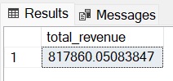
2.Average Order Value:
SELECT SUM(total_price)/COUNT(DISTINCT order_id) AS avg_order_Value
FROM pizza_sales;
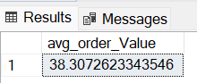
3. Total Pizzas Sold
SELECT SUM(quantity) AS total_piza_sold
FROM pizza_sales;
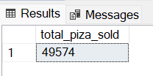
4. Total Orders
SELECT COUNT(DISTINCT order_id)
FROM pizza_sales;
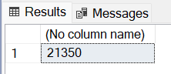
5. Average Pizzas Per Order:
SELECT 1.0* SUM(quantity)/COUNT(DISTINCT order_id) AS avg_Piza_per_order
FROM pizza_sales;
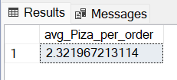

--Or
SELECT FORMAT(1.0 * SUM(quantity) / COUNT(DISTINCT order_id), 'N2') AS avg_Pizza_per_order
FROM pizza_sales;
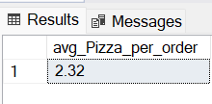

B. Daily Trend for Total Orders
SELECT DATENAME(DW, order_date) AS order_day, COUNT(DISTINCT order_id) AS total_orders
FROM pizza_sales
GROUP BY DATENAME(DW, order_date);
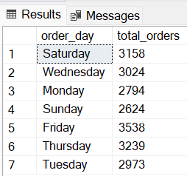

C. Hourly Trend for Orders
SELECT DATEPART(HOUR, order_time) as order_hours, COUNT(DISTINCT order_id) as total_orders
from pizza_sales
group by DATEPART(HOUR, order_time)
order by DATEPART(HOUR, order_time);
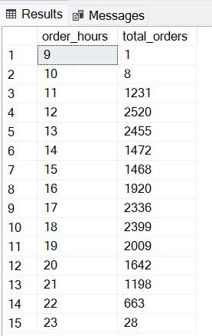
D. % of Sales by Pizza Category
SELECT
pizza_category,
ROUND(SUM(total_price), 2) AS total_revenue,
ROUND(SUM(total_price) * 100.0 / SUM(SUM(total_price)) OVER (), 2) AS pct
FROM pizza_sales
GROUP BY pizza_category;
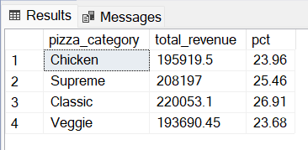
E. % of Sales by Pizza Size
SELECT pizza_size, CAST(SUM(total_price) AS DECIMAL(10,2)) as total_revenue,
CAST(SUM(total_price) * 100 / (SELECT SUM(total_price) from pizza_sales) AS DECIMAL(10,2)) AS PCT
FROM pizza_sales
GROUP BY pizza_size
ORDER BY pizza_size;
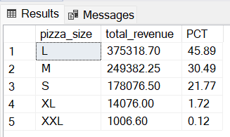
F. Total Pizzas Sold by Pizza Category
SELECT pizza_category, SUM(quantity) as Total_Quantity_Sold
FROM pizza_sales
WHERE MONTH(order_date) = 2
GROUP BY pizza_category
ORDER BY Total_Quantity_Sold DESC;
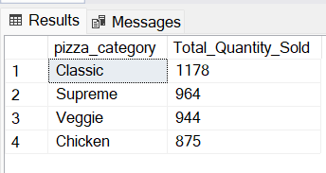
G. Top 5 Best Sellers by Total Pizzas Sold
SELECT Top 5 pizza_name, SUM(quantity) AS Total_Pizza_Sold
FROM pizza_sales
GROUP BY pizza_name
ORDER BY Total_Pizza_Sold DESC;
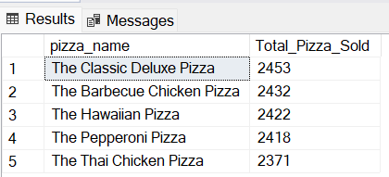

H. Bottom 5 Best Sellers by Total Pizzas Sold
SELECT TOP 5 pizza_name, SUM(quantity) AS Total_Pizza_Sold
FROM pizza_sales
GROUP BY pizza_name
ORDER BY Total_Pizza_Sold ASC;
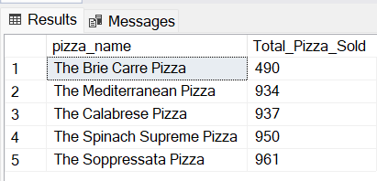

NOTE
If you want to apply the Month, Quarter, Week filters to the above queries you can use WHERE clause. Follow some of below examples
SELECT DATENAME(DW, order_date) AS order_day, COUNT(DISTINCT order_id) AS total_orders
FROM pizza_sales
WHERE MONTH(order_date) = 1
GROUP BY DATENAME(DW, order_date)

*Here MONTH(order_date) = 1 indicates that the output is for the month of January. MONTH(order_date) = 4 indicates output for Month of April.

SELECT DATENAME(DW, order_date) AS order_day, COUNT(DISTINCT order_id) AS total_orders
FROM pizza_sales
WHERE DATEPART(QUARTER, order_date) = 1
GROUP BY DATENAME(DW, order_date)

*Here DATEPART(QUARTER, order_date) = 1 indicates that the output is for the Quarter 1. MONTH(order_date) = 3 indicates output for Quarter 3.

